**USER MANUAL**

**YELLO APPLICATION**

**Registration**

1. Install Yello.apk file.
2. Tap on ‘YELLO’ icon on your screen to open Yello App.
3. Registration screen will appear on the screen as below:

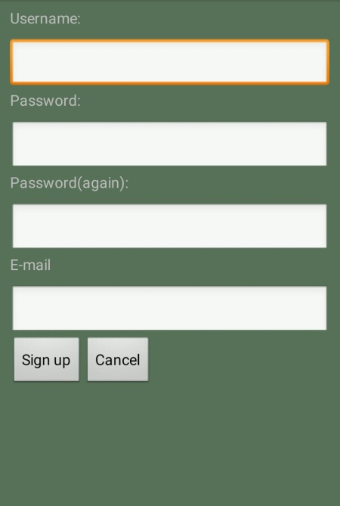

1. Enter required detail such as Username, Password, Email ID and sign up.
2. After signing up, you will be directed to OTP page:

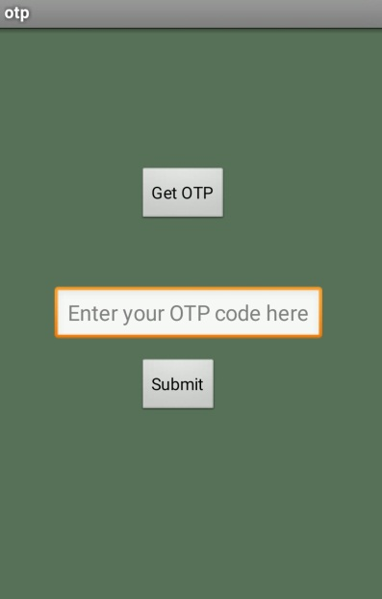

1. Tap on ‘Get OTP’.
2. After tapping on Get OTP. One toast will appear containing OTP.

Enter that OTP in the box and submit.

1. After submitting correct OTP, your account will be generated on Yello App server.

**AppLock**

1. As soon as your account is created, you need to set AppLock pin.
2. Note that your initial password is ‘hello’.

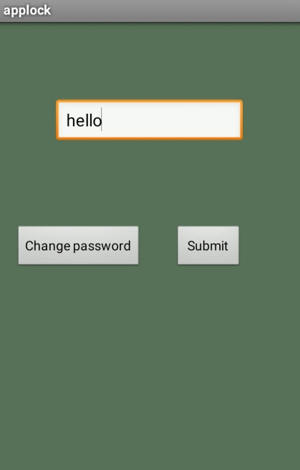

1. After entering initial password, you can set your own password.
2. Every time, when you open Yello App, you have to enter password, so that any other person cannot use your app.

**Homepage**

1. After setting Applock, Homepage will be opened.

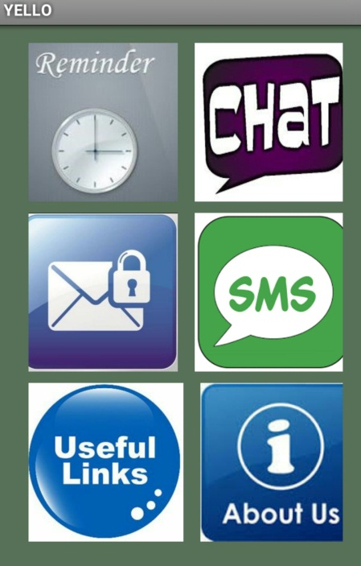

1. You can choose any one of the activities by tapping on the icon.

**Reminder**

1. Suppose you tap on first Reminder icon, then Reminder will be opened.

2. You can set reminder here,

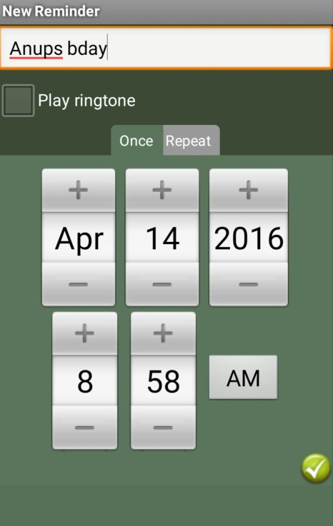

E.g. here reminder of Anup’s bday is set, on April 14th, 2016, 8:58 AM.

You can use add(+) and minus(-) signs to increase or decrease the any number(i.e, hours, date, year etc.) and month respectively.

1. After setting this reminder, it will look like as below:



1. You can add more reminders by tapping on clock icon, at the top right of the screen.
2. To change settings, tap on settings icon at the top right of the screen.

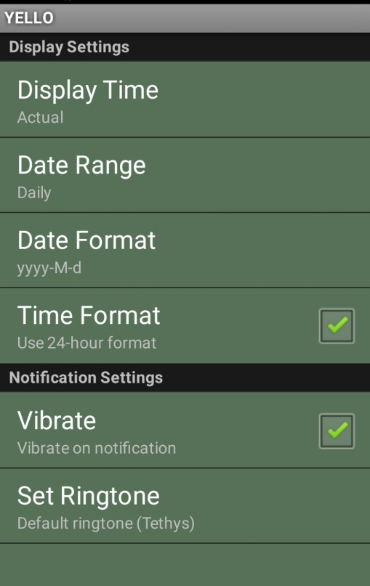

**Secure Messaging**

1. To send secured messages, tap on Secure Messaging icon on the homepage of Yello App

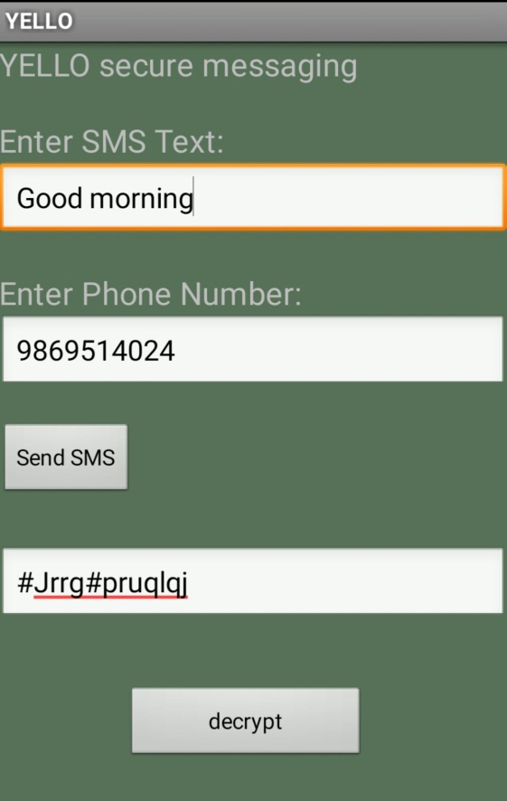

1. Enter text, phone no. and send SMS. Thus encrypted message will be sent to another user.

**Useful Links**

1. Tap on Useful links icon on the homepage of Yello App.



1. These are the important links, which user might require to visit while using this App.

**Online Chat**

1. Tap on Online Chat icon on the homepage of Yello App.
2. If you are opening for the first time, or if you don’t have any friend in friend list then the screen will appear as follow:

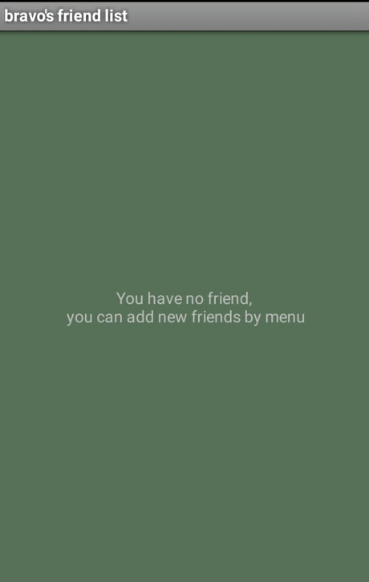

1. You can add friends, by sending add friend request to your friend.

Notification will appear on your friend’s notification bar, and then he/she can accept or reject your friend request.



Here, Bravo has ajaym in his friend list. Green coloured box in front of friend’s name denotes that he is online and red coloured box denotes he is offline.

1. Tap on friend’s name to chat with that friend.

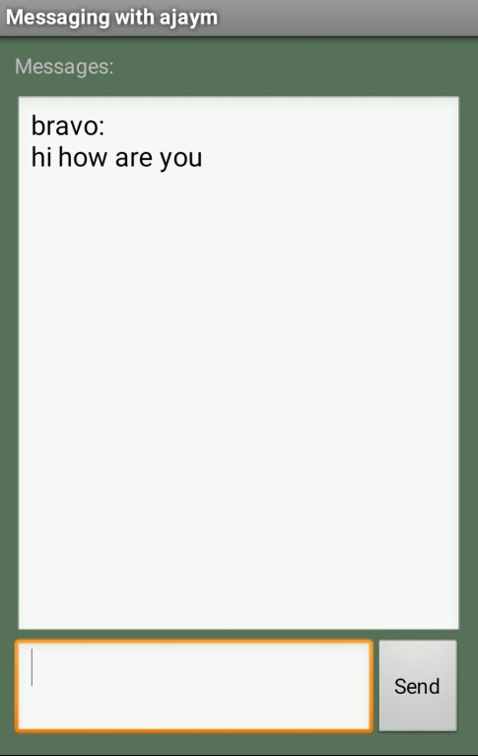

Type your message in the box and tap on send button.

1. Messages sent by your friend will appear on same page

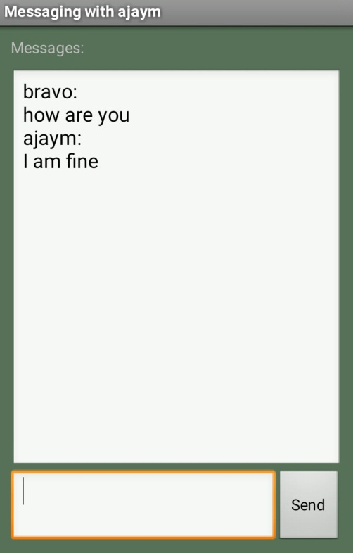

**Offline messaging**

1. To send message offline, tap on SMS icon on homepage
2. Enter your text and phone no. and tap on send SMS.

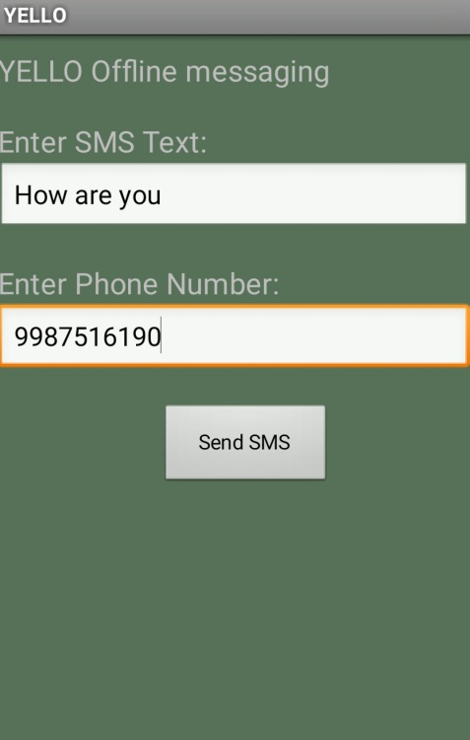

1. For offline messaging standard SMS charges are applied.